Greening Your Home

Reducing your personal greenhouse gas emissions

Did you know that by our everyday habits and choices, the average American puts out 22 tons of carbon dioxide (CO2) per year? Experts studying the recent climate history of the earth agree now that global warming is occurring at a precipitous rate, and human activities are the dominant force driving the trend. Our smokestacks, tailpipes, and burning forests emit CO2 and other gasses that add to the planet’s natural greenhouse effect, allowing sunlight in, but preventing some of the resulting heat from radiating back to space. Many climate experts say that without big curbs in greenhouse gas emissions, the 21st century could see temperatures rise 3 to 8 degrees, weather patterns sharply shift, ice sheets shrink, and seas rise several feet. The problem of global warming seems overwhelming, but there is a lot you can do to help. Reducing your personal share of global warming emissions is easier than you think.

If every U.S. household replaced six regular 60-watt bulbs with compact fluorescent light bulbs (CFLs) it would be equivalent to removing roughly four million cars from the road – permanently.

Small Steps to Take in Your Home and Yard

All of us are capable of making a few small changes in our home and yard that can lead to big reductions in greenhouse gas emissions, increase the nation's energy independence, and save money on energy bills.

Change your light bulbs

Replace the conventional bulbs in your most frequently used light fixtures with bulbs that have the Energy star label, such as CFL bulbs. If every household in the U.S. took this one simple action we would prevent more than 1 trillion pounds of greenhouse gas emissions.

Use Energy Star labeled products and maintain appliances

Energy Star products are available in more than 50 product categories, including lighting, appliances, and home electronics. If your fridge door can't hold a dollar, you're leaking CO2 and money, as well as cold air, so get it fixed. You also save by cleaning your refrigerator's coils, defrosting regularly, and keeping the top shelf clear of clutter.

Heat and cool your home efficiently

Use a programmable thermostat, which will automatically adjust your home's temperature while you're asleep or away. Also, clean your air filters regularly, especially during winter and summer months, and have your heating and cooling equipment tuned regularly by a licensed contractor. Install adequate insulation, seal the cracks and gaps in your house, and replace old windows with windows that qualify for the Energy Star. If all this seems too overwhelming, a home energy auditor can help to identify areas with poor insulation and evaluate the energy efficiency of your home.

Reduce, reuse, and recycle

If there is a recycling program in your community, recycle your newspapers, beverage containers, paper, and other goods. Buy products made from recycled materials or in containers that can be recycled, and use items that can be repaired or reused.

Be green in your yard

Opt for a push mower, which, unlike a gas or electric mower, consumes no fossil fuels and emits no greenhouse gases. If you must use a power mower, make sure it is a mulching mower to reduce grass clippings and add natural compost to your lawn. Composting your food and yard waste reduces the amount of garbage that you send to landfills and reduces greenhouse gas emissions.

Use water efficiently

Municipal water systems require a lot of energy to purify and distribute water to households, and saving water, especially hot water, can lower greenhouse gas emissions. Don’t let the water run while shaving or brushing your teeth, don’t flush the toilet unless necessary, and repair leaky toilets and faucets right away.

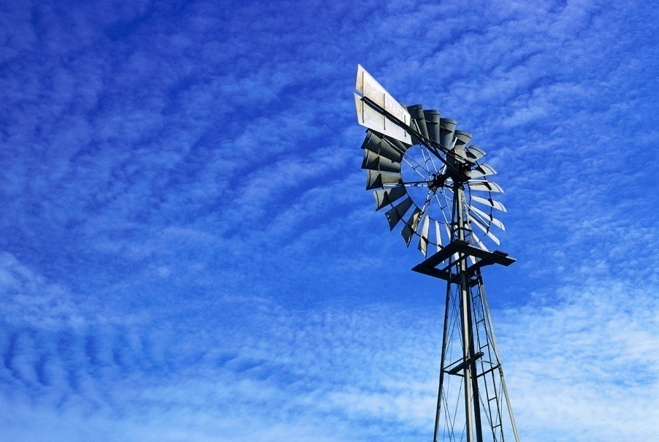

Use Green Power

Green power is environmentally friendly electricity that is generated from renewable energy sources, such as wind and the sun. There are two ways to use green power: you can buy green power for your home, or you can modify your house to generate your own green power, for example, by installing solar panels.

What are renewable energy resources?

Renewable energy resources are continuously replenished and include wind, solar, geothermal, low impact (small) hydropower, biomass (wood, straw, manure), and biogas. All of these resources reduce the environmental impact associated with traditional power generation. Currently, the majority of electricity in the U.S. is generated from fossil fuels, with less that 2% generated from non-hydro or biomass renewable resources.

*Sources: www.epa.gov and www.thegreenguide.com.*